# SIT107 – 10.2D

### Sprint 2 Data Collection

### Tiffany Gray

### 218518691

### Gregory S McIntyre

### 218356779

The modification of the IOT HR Monitor (IOT HR) into the Logger HR Monitor (Logger HR) was necessary to implement the ability to collect data for the process of analysis and visualisation. To modify the IOT HR Monitor we had to modify only the ACT of the Sense-Think-Act cycle.

As per the IOT HR Monitor design the Logger HR Monitor used a simple pulse monitor for the sense cycle, sensing the analog pulse values. The IOT HR and Logger HR both use upper and lower thresholds to interpret a beat, added to a count over a four second period to calculate a simple beat per minute measure. As the IOT HR output data in Realtime to a locally generated web server, it required no data collection, the Logger HR outputs the data to a CSV File.

how you may potentially use that data for analysis and decision-making in Task 11.1D.

The goal for our sprint was to create a HR monitor to collect the beats per minute data for further analysis.

“As a user with a medical history of cardiac problems, I want a way to be able to determine if I have a regular heart rate and collect that data for further analysis.”

“As a designer I want to use a heart rate monitor as well as Realtime clock and data logger to make a heart rate monitor capable of recording bpm data for further analysis.”

#### Group member roles/tasks.

**Tiffany Gray –**Presentation, Visualisations

**Greg McIntyre –** Think, Act

##### YouTube demonstration link

<https://youtu.be/f9--gN78zJ4>

#### Trello Link

<https://trello.com/b/O5xWVgtD/iot-hr-monitor>

#### GitHub Link for Burndown

<https://github.com/gregorymcintyre/SIT107-Team-Project-Sprint-1>

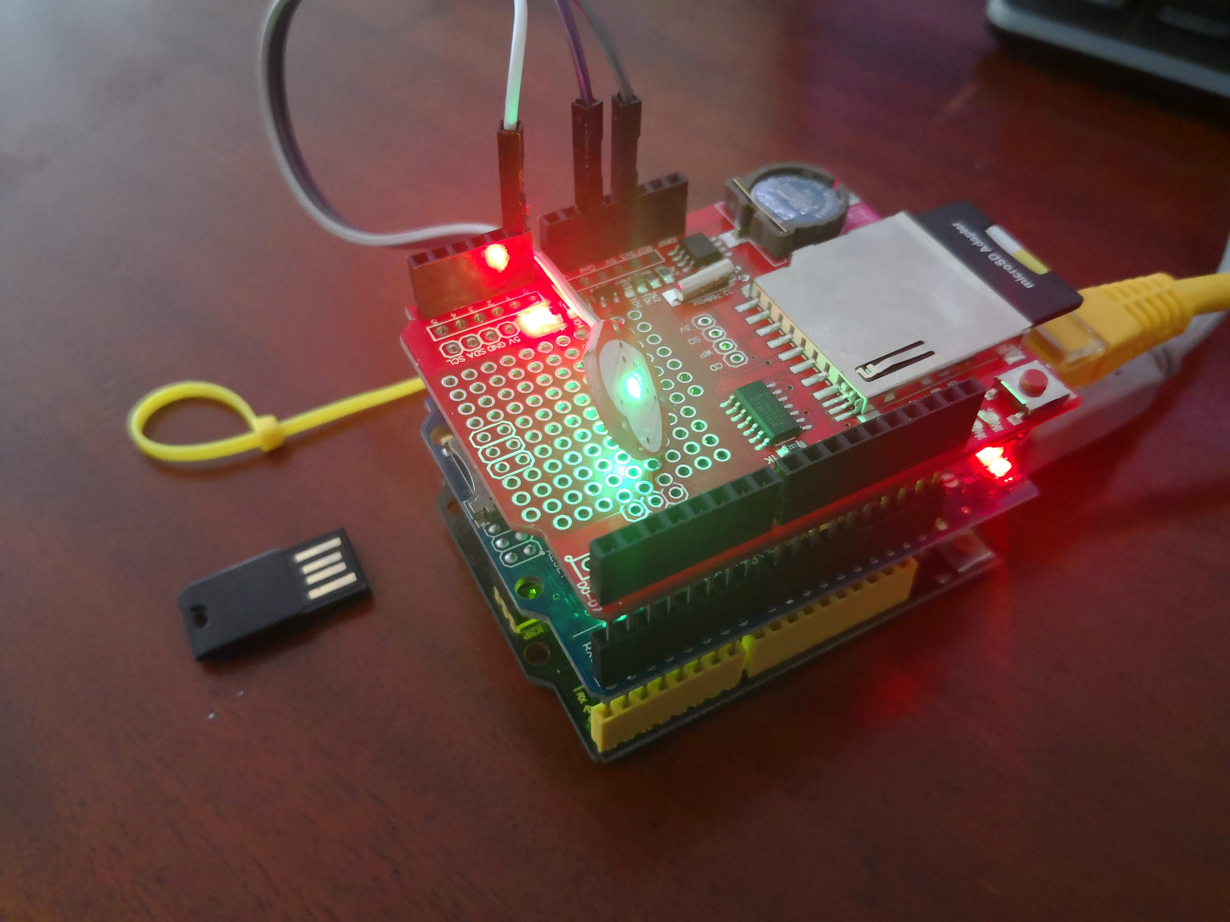

Figure : Logger HR Monitor

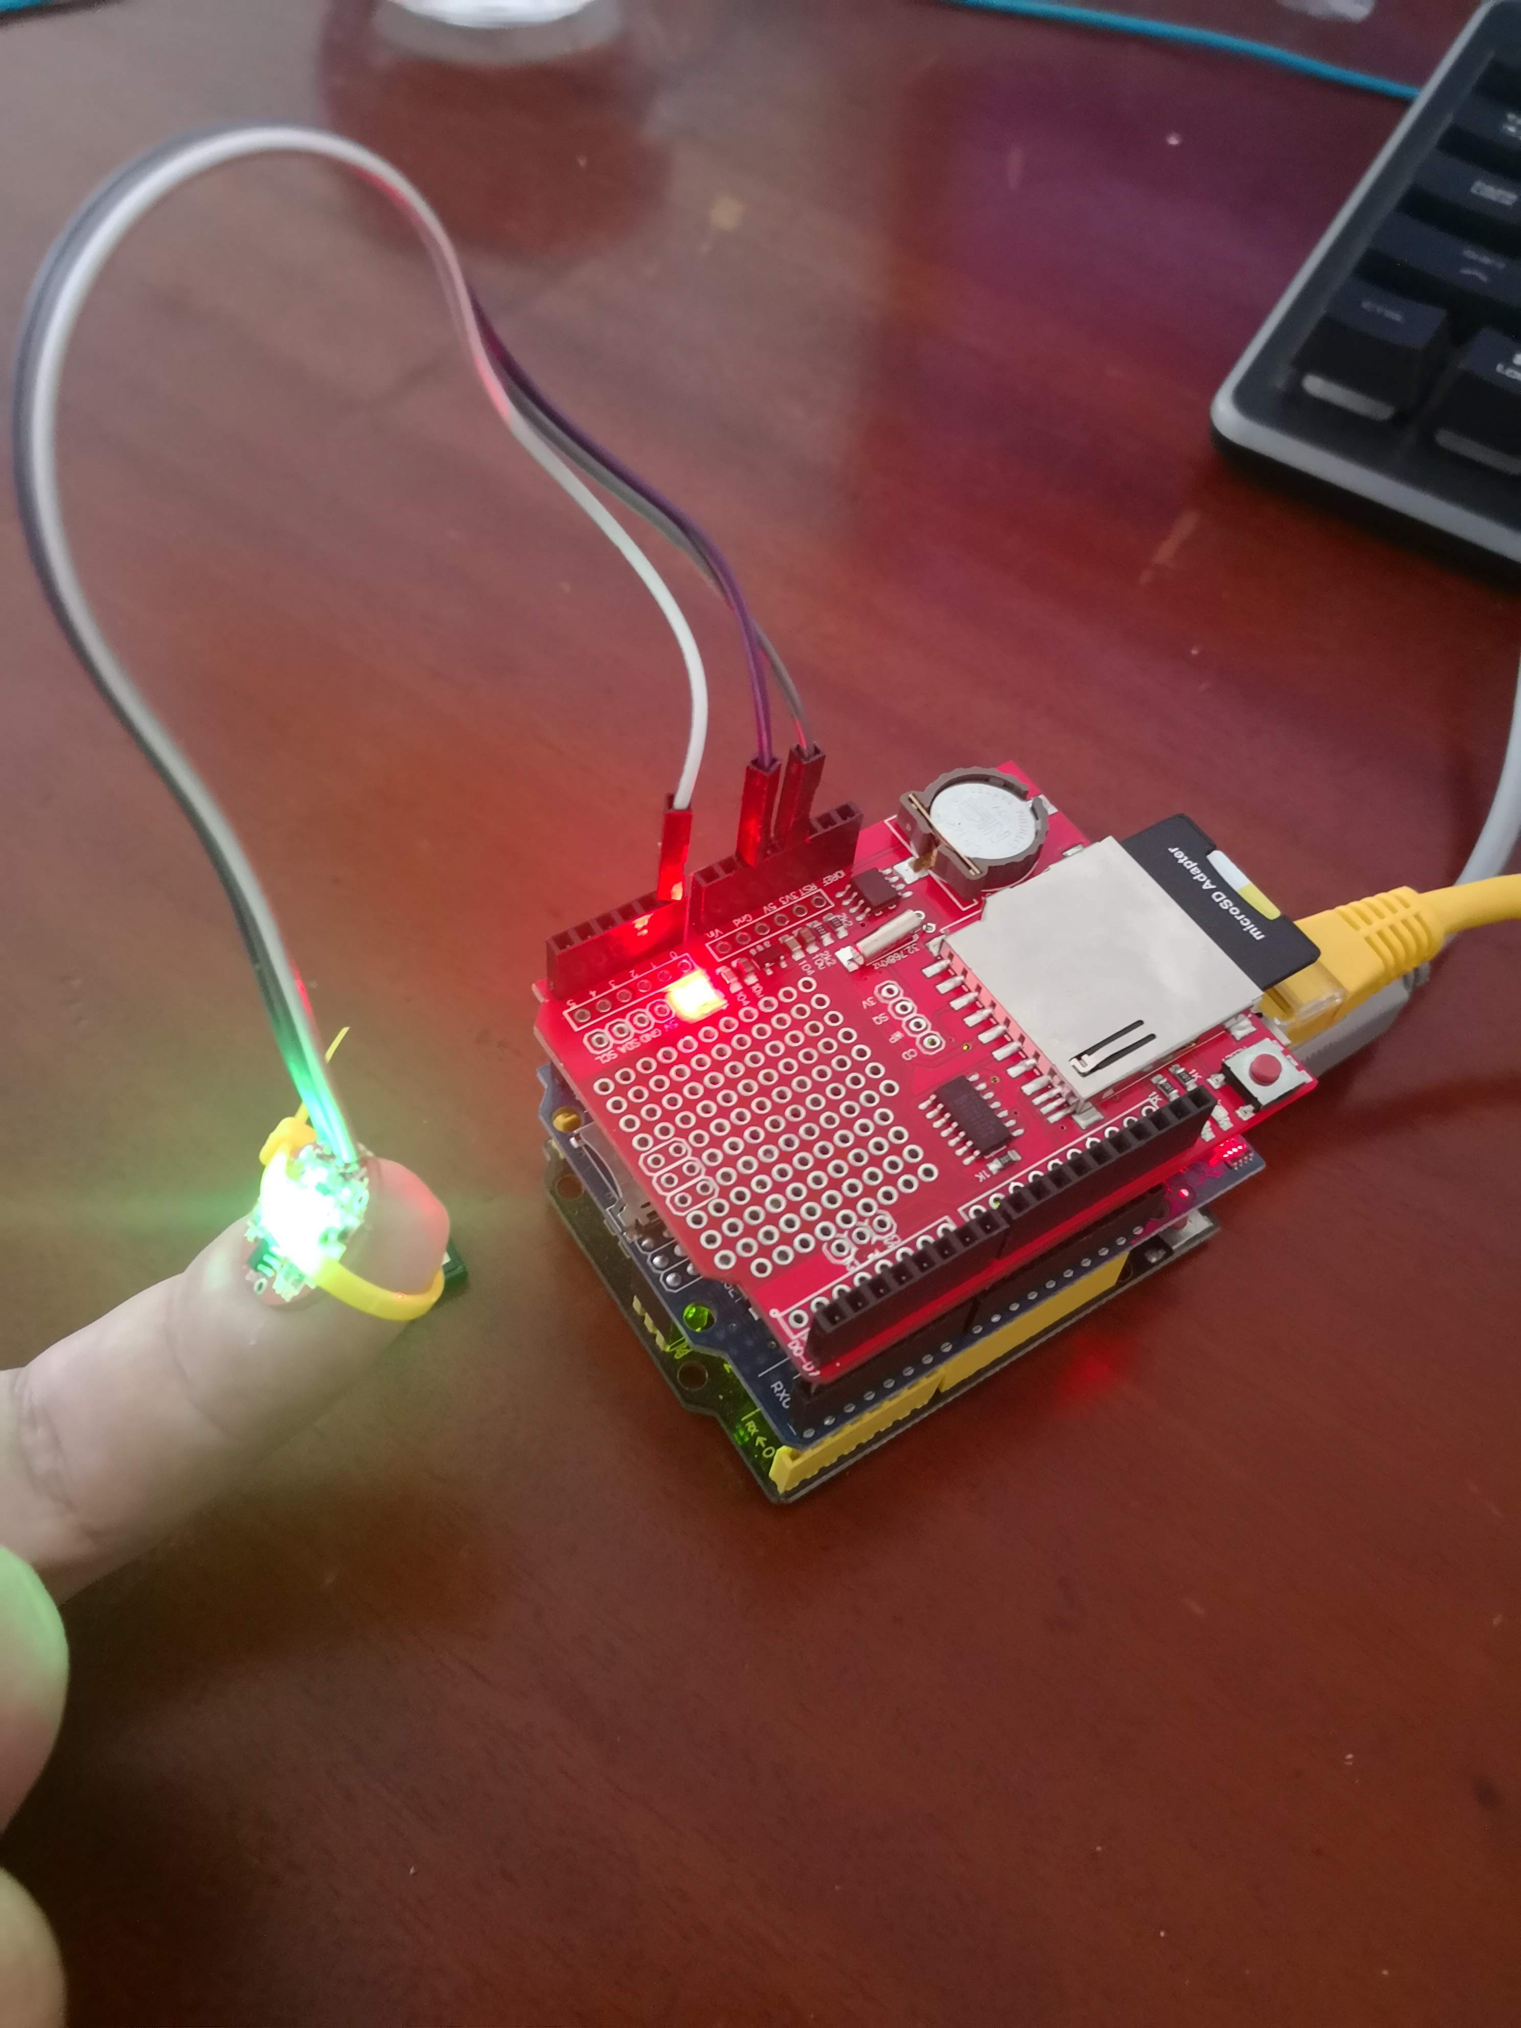

Figure : Application/Testing

This development of the IOT HR monitor into the Logger HR monitor was not overly challenging, as the team had a very good understanding of the original project it was just a case of implementing the data logger from <https://github.com/niroshini/motion_data_logging>. No overly significant challenges were met. Future developments maybe limited as we near the limits of the UNO, although unrefined, this project uses 71% of storage space and 82% of dynamic memory at this point of development.

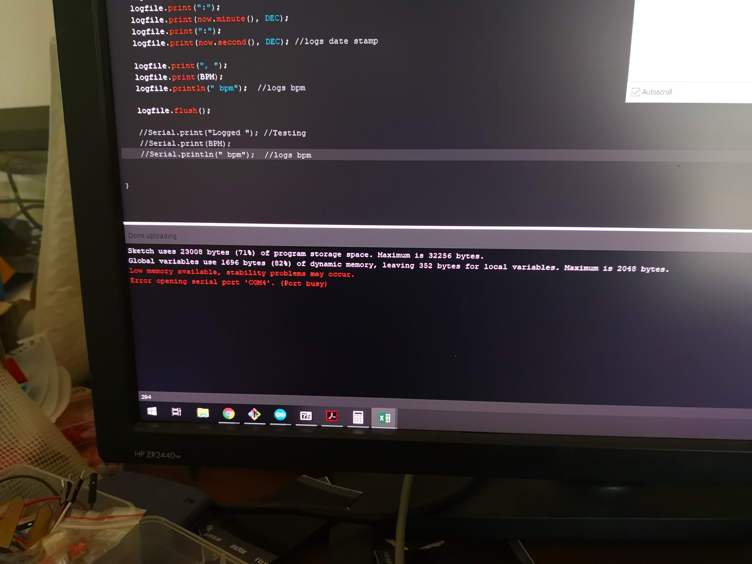

Figure : Hardware Limitations